Assignment 5

**Create a public bucket in AWS.Upload a file and give the necessary permission to check the file url is working or not.**

**Steps for creating an AWS account:**

1. **Sign in.** Sign in as a root user. Provide username and password when prompted.
2. Search on the search bar **S3**. After that click on **bucket** in the **S3**.

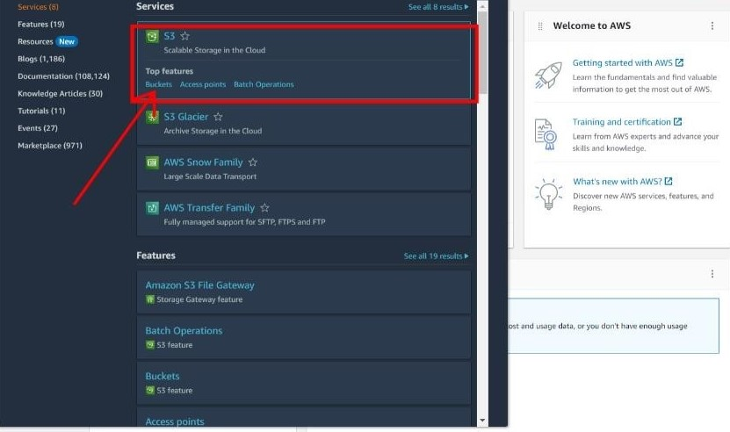

1. Now click on **Create bucket**.

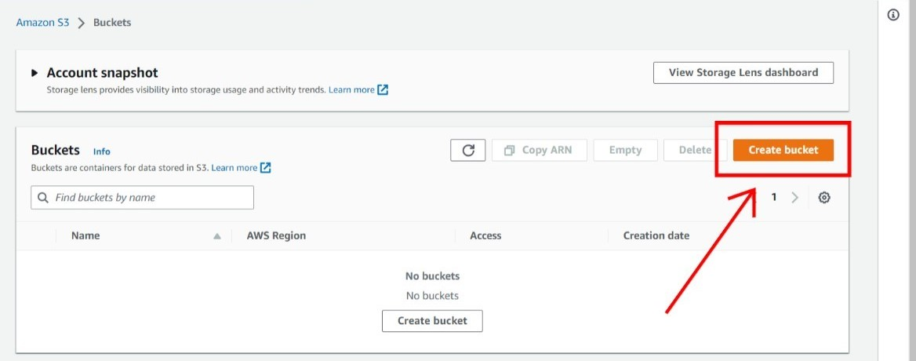

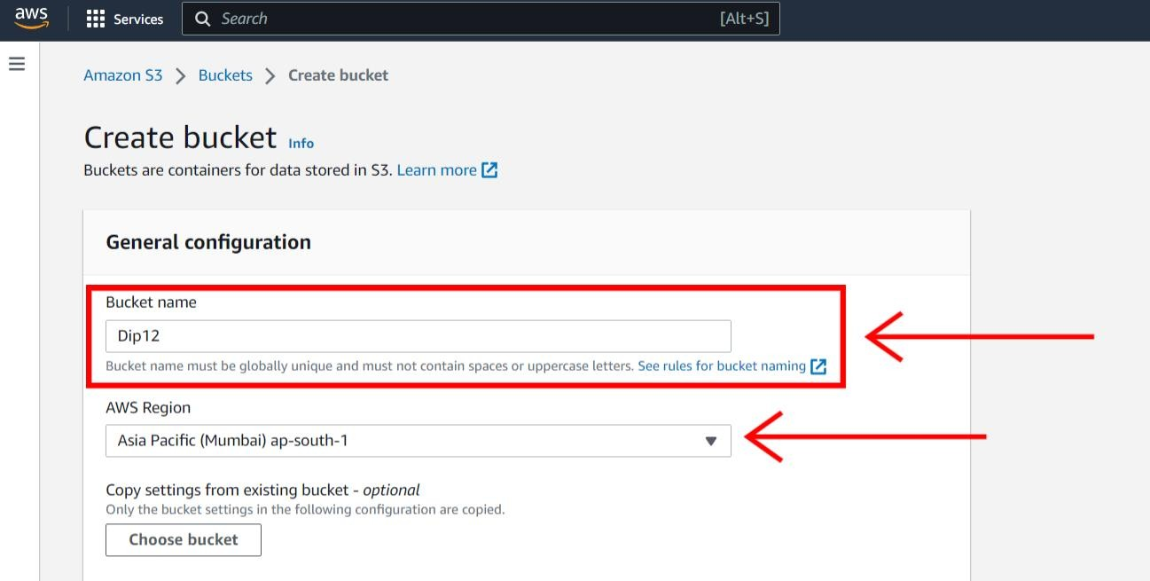

5. Now click on **ACLs enable**. After that click on **Bucket owner preferred**.

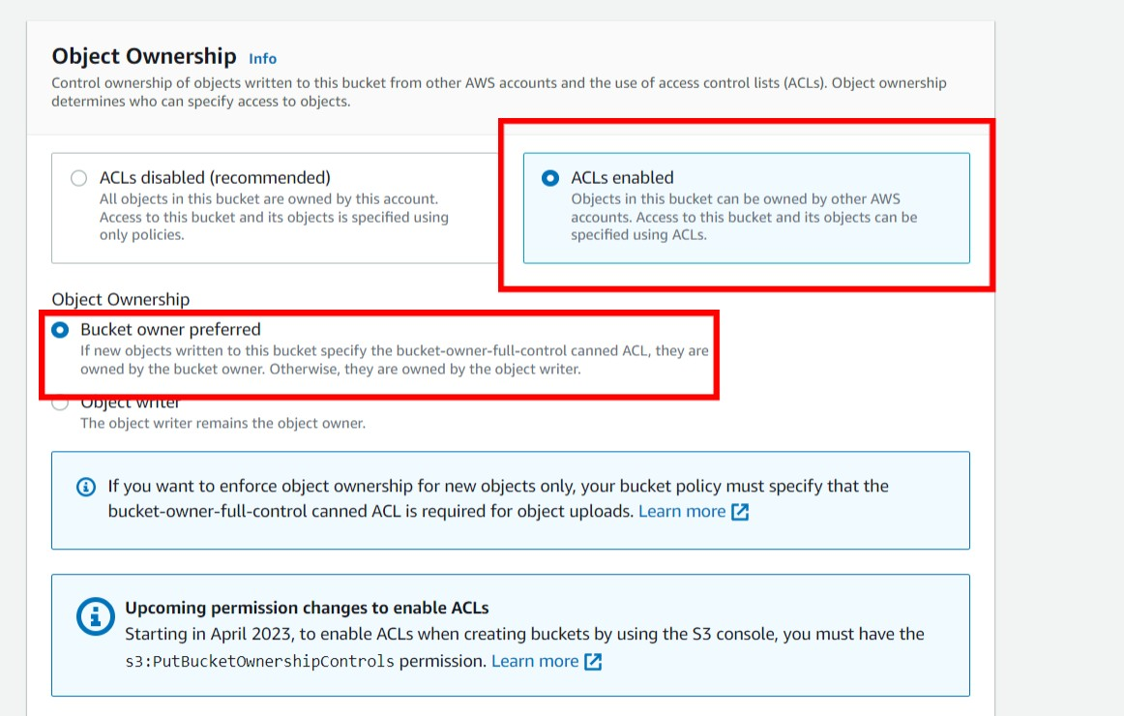

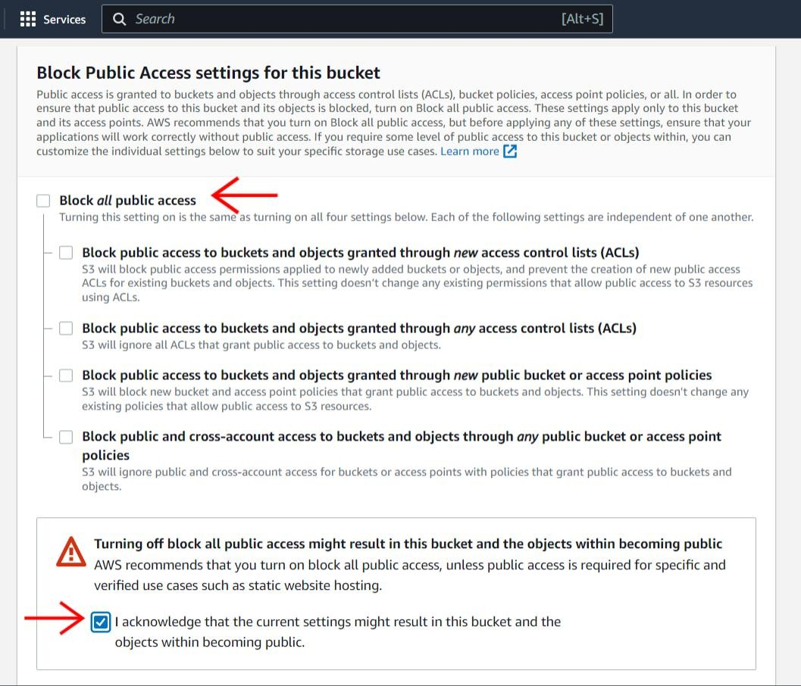

7. Now give the **Bucket versioning** as **disable.**

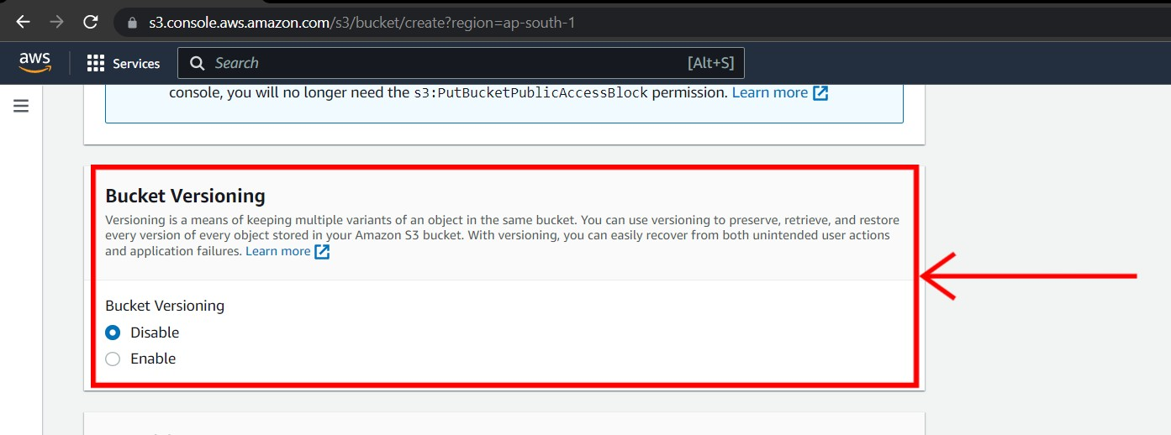

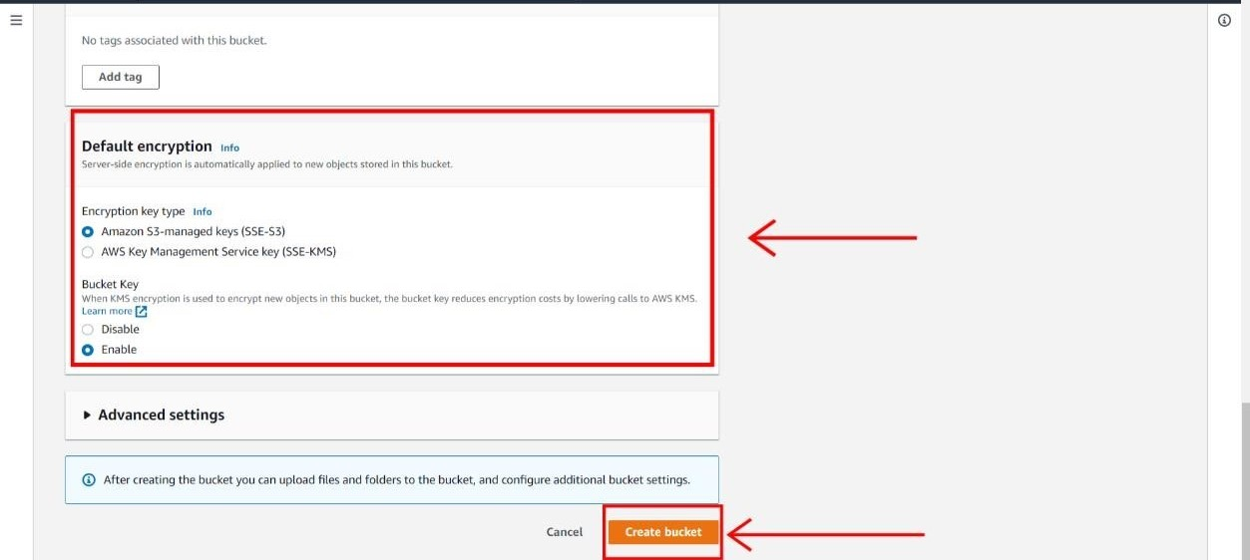

1. After your bucket has created click on the **bucket name**.

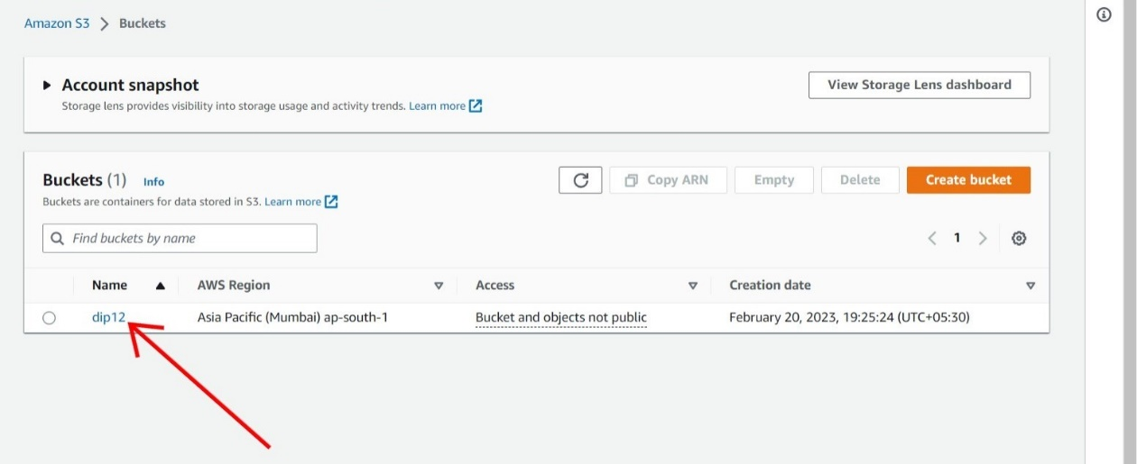

1. After that click on **upload** to upload **files or folders**.

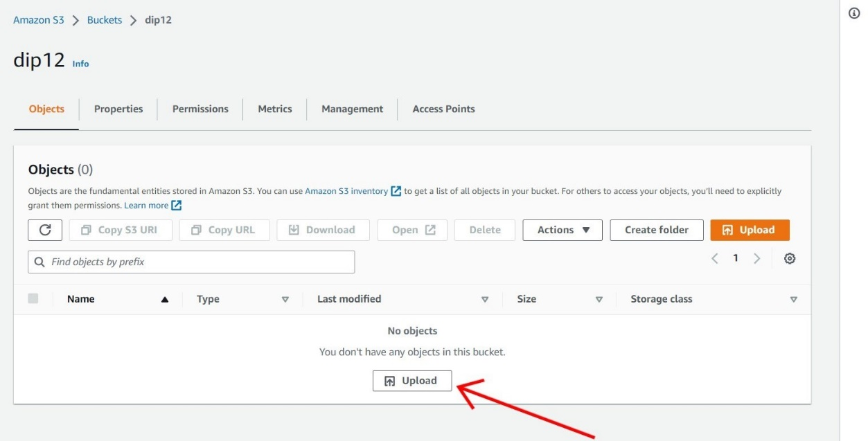

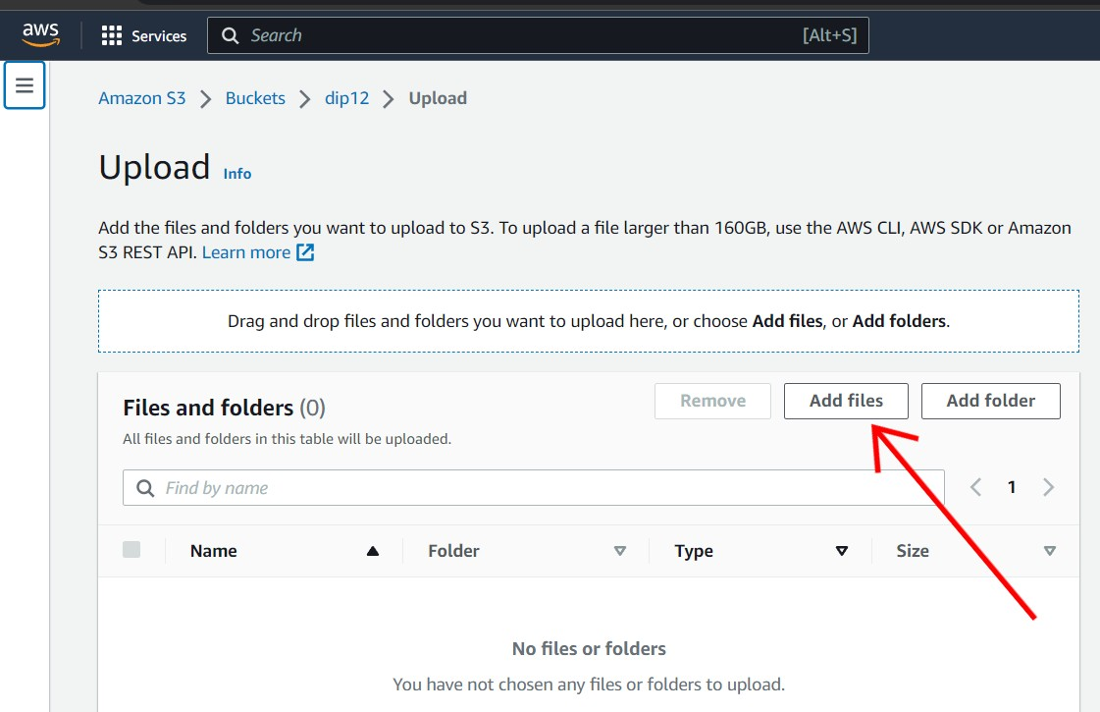

1. After that click on **upload**.

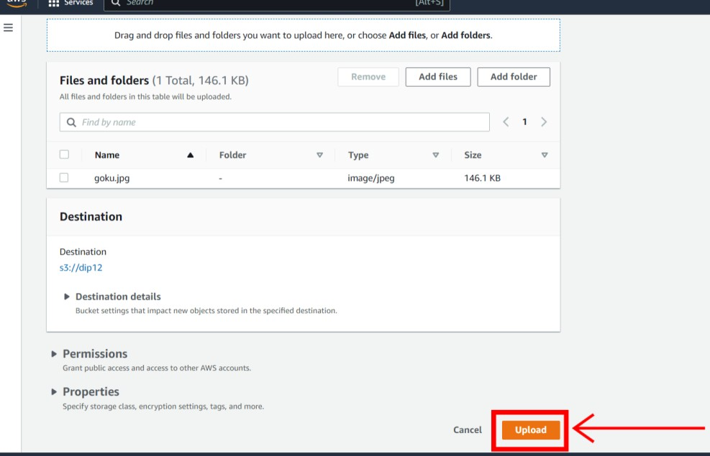

1. Now click **Close**.

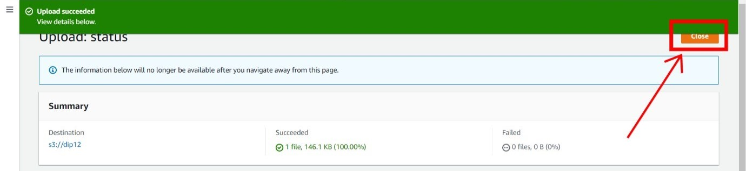

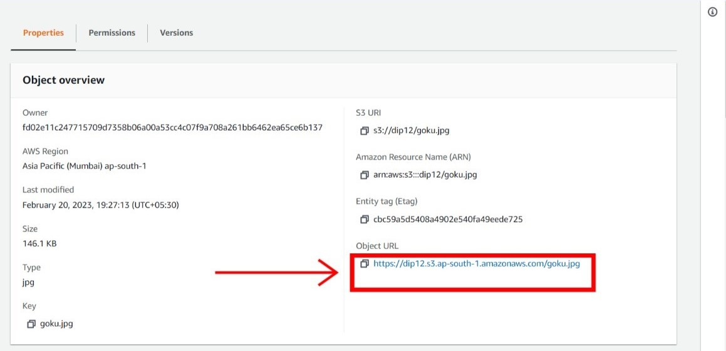

1. As we have not given the permission as public we can’t able to see the file.

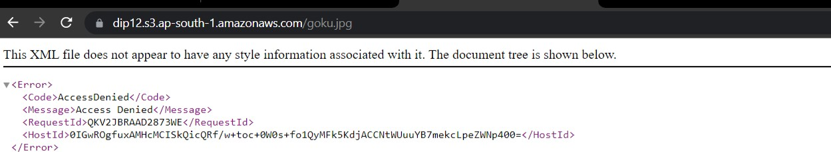

1. Now click on **permission**, after that click on **edit**.

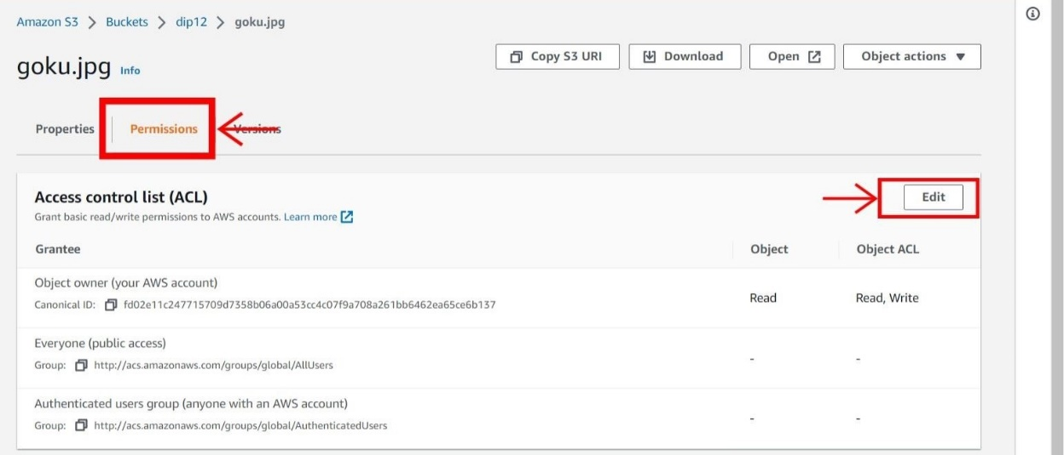

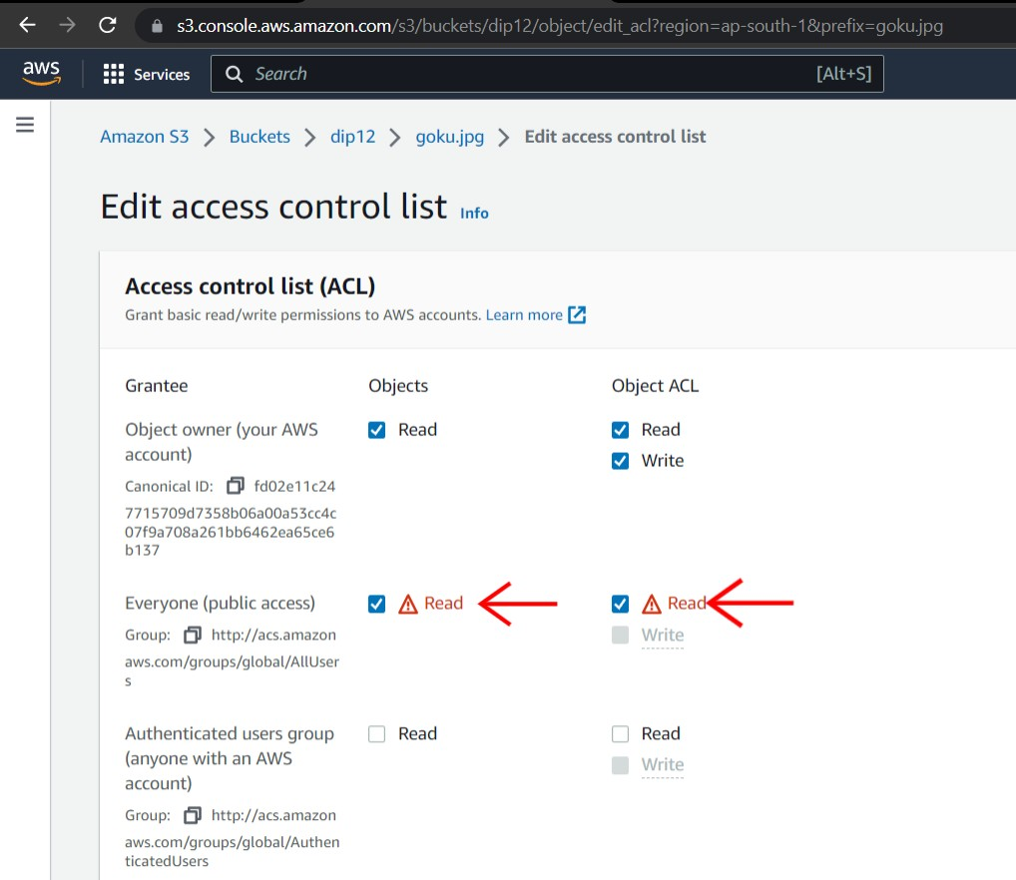

18. Check on **I understand**.

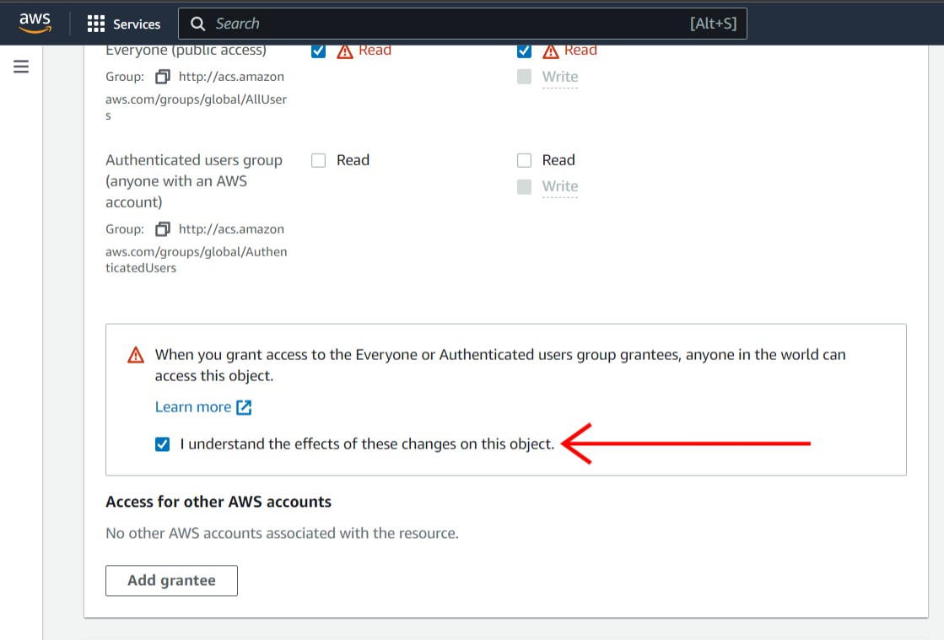

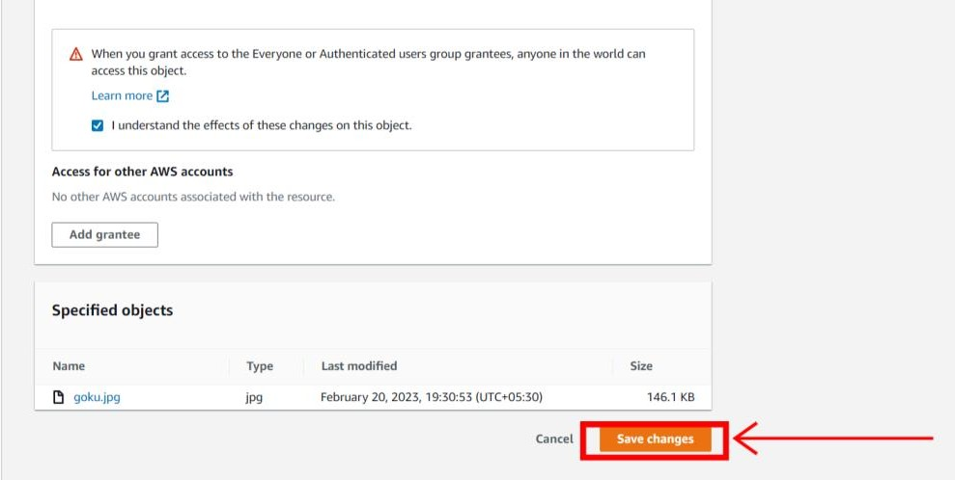

20. Now if you copy the object URL and open in new tab you can see the file which I have uploaded.

